CHAPTER EIGHT
Hazardous Materials Identification

Contents:
- 704 Fire Diamonds
- HAZ MAT ID Signage

Purpose:
Emergency responders must be aware of any Hazardous Materials involved in any emergency. This signage will help protect emergency responders by identifying hazard types in locations where hazardous materials exist.

HAZARDOUS MATERIALS IDENTIFICATION
(NFPA 704 FIRE DIAMOND)

- The sign plate shall be square with a thickness of .080 aluminum construction with radius corners. Size to be determined by the Fire Inspector or Fire Code Official.
- The sign face shall have a reflective vinyl background.
- Font style used – Numbers: Helvetica bold extended letters: Helvetica black BT.
- Numbers shall be a minimum of 5 ¾ inches high with 1 1/8-inch stroke width lettering for white special hazard box shall be minimum of 2 inches high with 6/16-inch stroke.
- Numbers and letters shall be black.
- Signs shall be posted at locations as required and approved by the Golder Ranch Fire District.

NFPA 704 PLACARD EXAMPLES
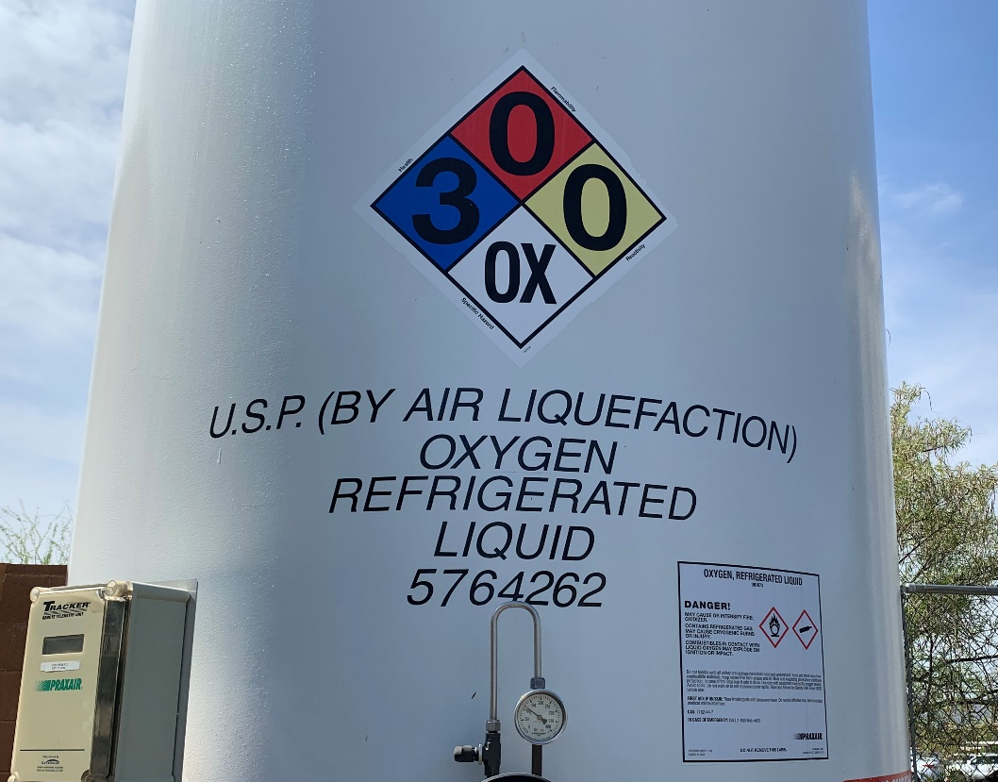

FIRE DEPARTMENT SPECIAL APPLICATION
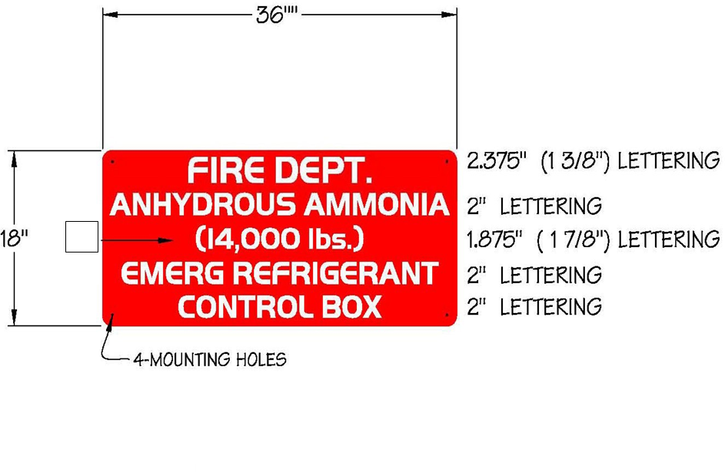
HAZ MAT SIGN

- The sign plate shall be a minimum of 36x18 inches with a thickness of .080 aluminum construction with 1½ inch radius corners.
- Font style is Handel Gothic capital fonts.
- The sign face shall have a white 3M diamond-grade reflective sheeting (3990 series VIP type IX) applied as a background.
- Lettering/Graphics shall be one of the following:
  - 3M Scotchlite electronic transparent cuttable film (1170 series) inverse cut to allow white reflective background to show through lettering.
  - Screen printed using 3M 8801 series red translucent ink.
  - Both processes (a or b) will accomplish a red field with white copy.
- Additional kerning between letters as shown.
- Number of pounds changes according to system.

