

CHAPTER SIX

Automatic Electric Gates

Contents:

* **Contractor Requirements**
* **Installation and Electrical Requirements**
* **Preemption**
* **Knox Key Switch Placement and Installation**
* **Automatic Gate Signage**
* **Gate Maintenance**

Purpose:

**Emergency responders need dependable access through gates to deliver prompt service. Design of access needs to be uniform.**

**GATE CONTRACTOR REQUIREMENTS**

**LICENSE REQUIREMENTS**

When installing, modifying or repairing a gate at any location that obstructs a fire apparatus access road, the gate contractor shall be licensed by the Arizona Registrar of Contractors. Accepted licenses are as follows:

1. To perform electrical work on gates: C-11 or CR-11
2. To install or modify gates: C-14, R-14 or CR-14

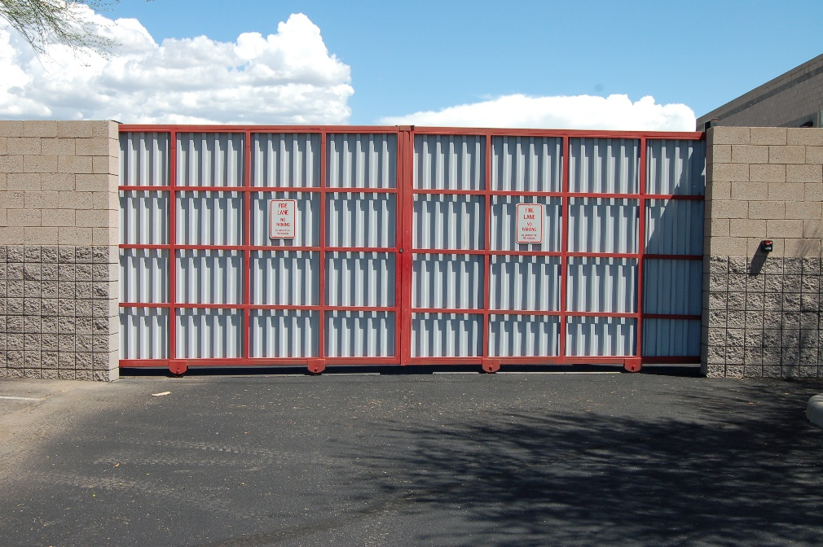

**REQUIRED PERMITS and PLAN SUBMITTALS**

A gate permit is required for all new gates and for modifications to existing automatic, electric gates.

In addition to the Golder Ranch Fire District gate permit, A SEPARATE BUILDING DEPARTMENT PERMIT IS REQUIRED for electric gates. Obtain the permit at the appropriate Building Department: Pima/Pinal County or Town of Oro Valley/Marana. Stamped, approved plans must be on site for all inspections.

Electrical inspections and approvals must be obtained prior to the final fire inspection.

**SITE PLAN REQUIREMENTS**

In addition to specific requirements detailed in this guide, site plans shall include the following information:

1. Name and address of the installing contractor.
2. Project location including address and suite numbers, if applicable
3. Orientation to streets, buildings and property lines
4. Graphic representation of the scale used on the drawing
5. Point of compass
6. Number of gates to be installed and their locations

**VEHICLE ACCESS GATE REQUIREMENTS**

1. Access gates shall be designed and installed such that they do not obstruct the egress or departure of emergency vehicles.
2. All clear openings as shown on plans shall be a minimum 20 feet clear width for BIDIRECTIONAL access roads and 14 feet clear width or larger for UNIDIRECTIONAL access roads.
3. Turning radius shall comply with AASHTO WB-40 turning radius requirements. When a 42-foot turning radius cannot be met, the fire code official may require additional clearance.
4. An approved KNOX KEY SWITCH SERIES #3500 shall be used for 24-hour Fire Department access. See Chapter 4: Knox Boxes, Key Switches, Etc. for Knox ordering details. The emergency key switch, when activated, shall bypass any occupant control and loop systems. When activated, the gate will remain in the open position until deactivated by the Fire Department. Only when deactivated will the gate resume normal operation.
5. The Knox key switch shall open both the entrance and exit gate(s) within 15 seconds when gate(s) are positioned in close proximity to each other. Gates shall remain in the open position until closed by operation of the electrical control device.
6. The Knox key switch shall be mounted between 5½ and 6 feet above grade (location shown on plan) on ENTRANCE side of gate. An additional key switch is required on the EXIT side of the gate when the gate does not automatically open on approach.
7. The Knox key switch shall be located within 12 inches of signage labeled “FD ACCESS”. See Chapter 3-10: Fire Department Access Sign Detail for sign specifications.
8. Preemption devices shall be installed on all automatic gates including single-family gated communities containing six or more homes and all multi-family gated communities, per Golder Ranch Fire District installation requirements outlined in this chapter.
9. Gate operator(s) shall open at a rate of one foot per second. Parking barrier arms will open or clear in approximately two seconds.
10. Automatic gate operator(s) and/or parking barrier arm(s) shall be equipped with battery backup on ENTRANCE and EXIT gates or be connected to an emergency generator.
11. Residential/multifamily gates will open on battery backup during loss of power and remain open until the power is restored (fail safe).
12. Gates on commercial/industrial properties remain closed until the emergency gate switch is activated, then open on battery backup (fail secure).
13. Electric gate operators shall be listed in accordance with UL325 (Standard for Door, Drapery, Gate, Louver and Window Operators and Systems). Gates intended for automatic operation shall be designed, constructed and installed to comply with requirements of ASTM F 2200 (Standard Specifications for Automatic Vehicular Gate Construction).

**ELECTRIC GATE ACCESS SYSTEM**

**APPROVED STROBE SWITCHES**

STROBESWITCH is a compact low-cost detector, which recognizes a coded strobe light signal from special emitters mounted on fire vehicles and ambulances. The system provides an output activation of the emergency access switch. In the Golder Ranch Fire District approved configuration, two detectors are used – one to sense entering emergency vehicles and another to facilitate quick exit. Both detectors are mounted on a rugged weatherproof power module that contains all additional processing circuitry. The assembly provides a dry relay closure signal to the gate operator and requires only 24 VAC input power to operate. Exit gates are permitted to open with an approved approach sensor or weight sensor in lieu of preemption devices installed on the egress side.

**HOW IT WORKS**

The emergency vehicle uses a special strobe light to transmit a continuously flashing optical signal. The TOMAR Model 2795-2 STROBESWITCH (or equivalent) receives this signal, and if the signal format is correct, activates a relay. The relay contacts may be used to control security gates, Fire Department garage doors, and other devices. Signaling is optical by line-of-sight, and the 2795-2 can operate indoors or outdoors, in bright sunlight, or in any weather. The unit is not susceptible to radio frequency interference, and uses digital frequency discrimination to reject unwanted signals, such as flashlights, emergency vehicle lighting systems, flashing signs, etc.

**HOW TO OBTAIN**

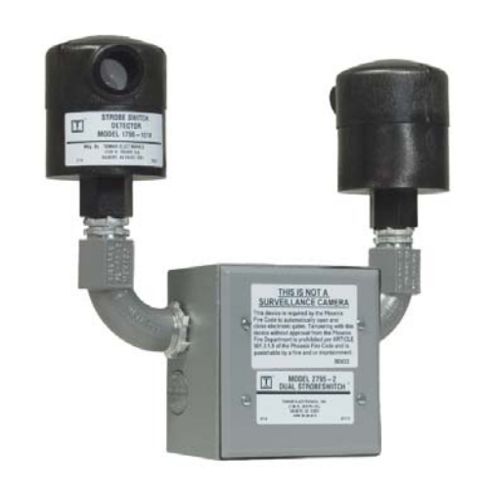Conduct an internet search for Gates and Operating Devices. Any authorized gate company licensed by the Arizona Registrar of Contractors with a C-14, R-14 or CR-14 license may perform the work.

**APPROVED ACCESS REQUIREMENTS FOR PREEMPTION DEVICES**

All electric gates shall be equipped with (or have installed) approved preemptive control opening equipment and a Knox key switch compatible with the Fire District’s existing system.

**MINIMUM STANDARD FOR INSTALLATION**

* + - Each gate shall have two approved individual Tomar detectors or an approved Tomar Dual Strobeswitch, model 2795-2 (or equivalent). Exit gates are permitted to open with an approved approach sensor or weight sensor in lieu of preemption devices installed on the egress side.
    - Individual detectors shall be mounted together with the power module in a dual detector mounting box, or with an approved Tomar Dual Strobe switch, model 2795-2 or equivalent.
    - Detectors shall be mounted 8 to 10 feet above grade.
    - Detectors shall be located a minimum of 18 inches behind the access gate on the property side when mounted on a dedicated post.
    - When used for mounting, metal posts shall be cemented a minimum of 18 inches below grade.
    - Detectors shall point toward the path of the emergency vehicle travel.
    - Detectors’ sight paths shall be free of visual obstructions such as signs, covered parking canopies, and vegetation.
    - Detectors shall activate at a minimum of 150 feet from gate.
    - An approved KNOX KEY SWITCH SERIES #3500 shall be provided as a manual backup. See Chapter 4: Knox Boxes, Key Switches, Etc. for Knox ordering information.
    - The entrance Knox switch shall be located above the keypad, where applicable. When mounted on the detector post, the Knox switch shall be mounted at 5½ feet to 6 feet above grade.

**ITEMS TO BE COORDINATED WITH GATE COMPANY**

1. A dedicated 15-AMP circuit breaker must be provided for each gate motor. (It is recommended to use a 20-AMP circuit breaker.)
2. 110-volt power must be provided to gate motors.
   1. Exception: Gate operators that run on low voltage or solar power.
3. A minimum ½ inch conduit shall be provided for:
   1. Service meter (electrical panel to master operator)
   2. Master operator to the slave operator, if applicable
   3. Closest operator to the preemption detectors
   4. Closest operator to Site Directory
   5. Telephone line, if applicable
   6. (¾ inch or larger conduit is recommended for best results)
4. It is recommended that two conduits be run to each device. Running low voltage and 110-volt wiring in the same conduit (even with properly rated wire) can cause cross talk, static and/or malfunctions and is not in compliance with the National Electrical Code.
5. Bury conduit a minimum of 24 inches under driveways and 18 inches in landscaped areas.
6. Landscaping shall not obstruct the sight path of preemption detectors.

Remember that these strict guidelines have been developed to protect the public (your customer) from unreliable installations, and above all, emergency response delays.

**ELECTRICAL REQUIREMENTS FOR NEW GATED COMMUNITIES**

1. The Electrical Site Plan must show:
   1. An individual branch circuit of a minimum 15-ampere and raceway of a minimum ½ inch serving each automatic gate. (20 ampere and ¾ inches or larger raceway/conduit is recommended.)
   2. The service equipment location and/or panel board location.
   3. The panel board schedule and new and/or revised load calculations.
   4. The location of the automatic gate operator(s), control equipment and actuation devices.
2. A separate electrical permit shall be obtained for each automatic gate through the Town of Oro Valley/Marana or Pima/Pinal County unless the vehicle gate(s) are shown on the scope of work for another permit. If the gates are included in another permit, make sure the gates are scheduled for a final electrical inspection before that permit is closed out.
3. Have conduit depth inspected for the gate operators, preemption detectors, resident keypad and Knox Key Switches prior to scheduling a final fire inspection.
4. Have final electrical inspection for gates. A passed final inspection must be obtained before the gate company can call for a Fire District inspection.
5. Items that will be inspected for electrical final:
   1. Electrical Underground for Gate
   2. Final Electrical Inspection for Gate
   3. Proper Grounding
   4. 110-volt connections
   5. Disconnect provided within site (NEC 2011, Article 430)

**MULTI-FAMILY RESIDENCE**

**PREEMPTED AUTOMATIC GATE DETAIL**

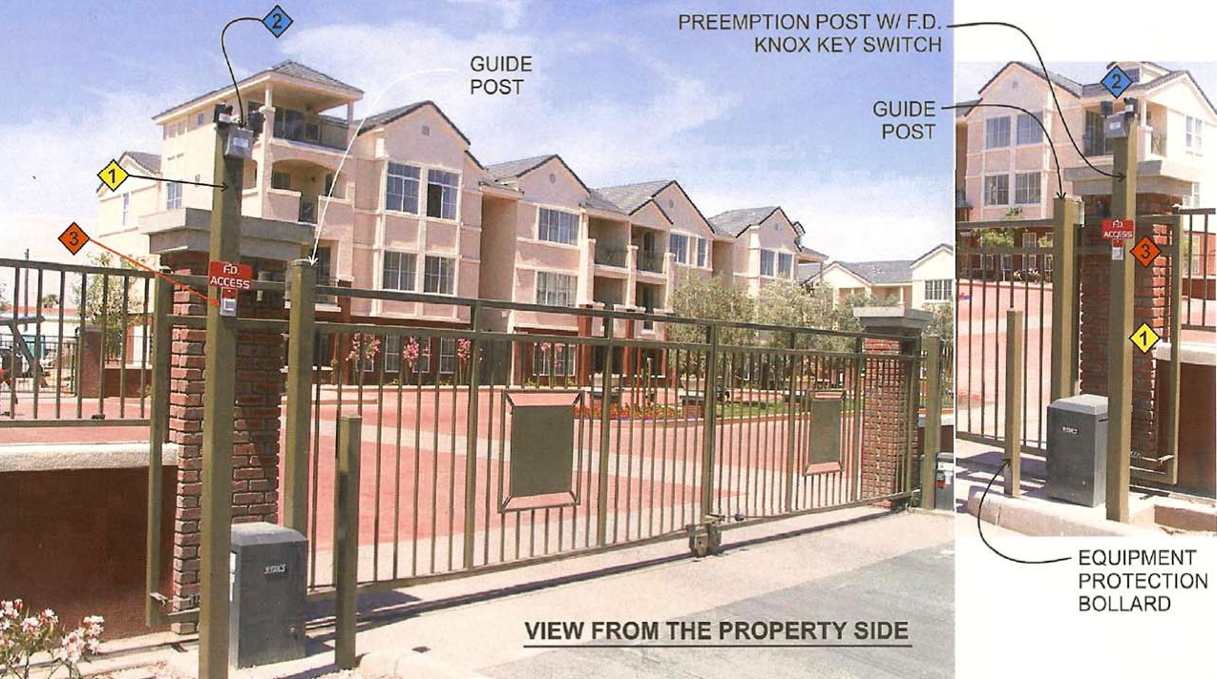

1. Detectors mounted on 4x4 inch post 8 feet to 10 feet above finished final grade.
2. Fire Department approved Tomar Dual Strobe Switch detector model #2795-2 or equivalent.
3. Fire Department approved KNOX KEY SWITCH #3500 series with FD Access sign. See Chapter 3-10: Fire Department Access Sign Detail for sign specifications and see Chapter 4: Knox Boxes, Key Switches, Etc. for Knox ordering information.

**TYPICAL ENTRANCE TO MULTIPLE RESIDENTIAL COMMUNITIES WITH AUTOMATIC GATES**

See Chapter 3-10 for sign detail

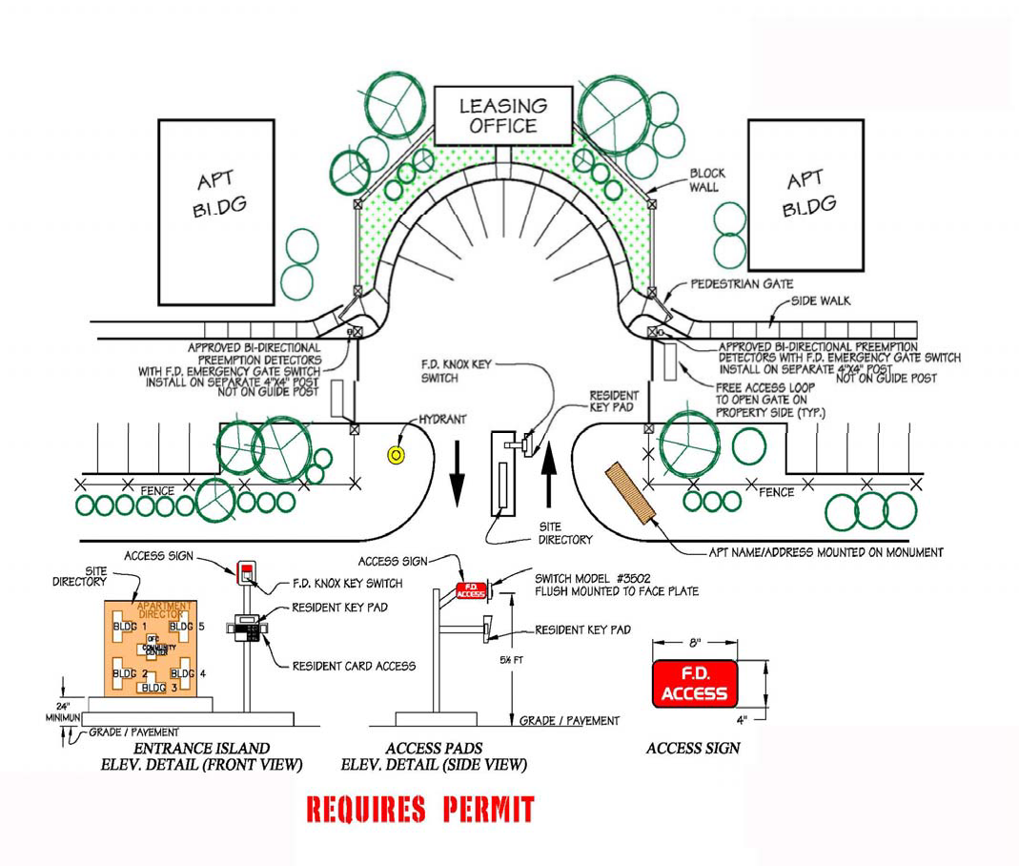

**AUTOMATIC GATE ENTRANCE WITH 3-STROBE DETECTORS DETAIL**

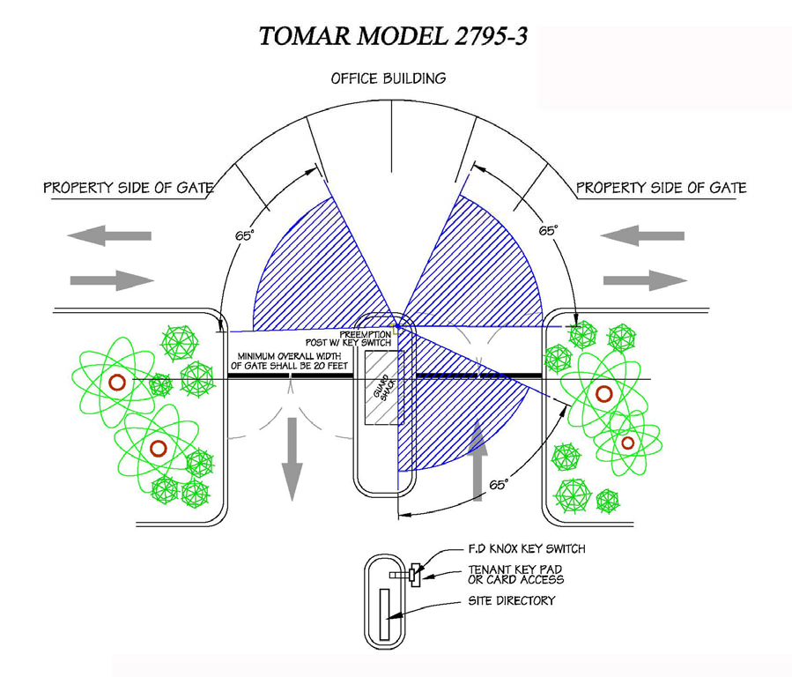

1. Detectors shall be mounted 8 to 10 feet from grade. Mirrors shall not substitute the requirements of multiple detectors per gate.
2. Detectors shall point toward the path of the emergency vehicles. Detectors must activate at a minimum of 150 feet from gate.
3. The power module shall be mounted in an electrical junction box.
4. An approved KNOX KEY SWITCH SERIES #3500 shall be installed on the entrance side of access gate. Entrance switch shall be located above the key pad, if applicable, at 5½ feet to 6 feet from grade. See Chapter 4: Knox Boxes, Key Switches, Etc. for Knox ordering information.

**TOMAR PREEMPTION DETECTOR MODEL 1790-1014**

**(or equivalent)**

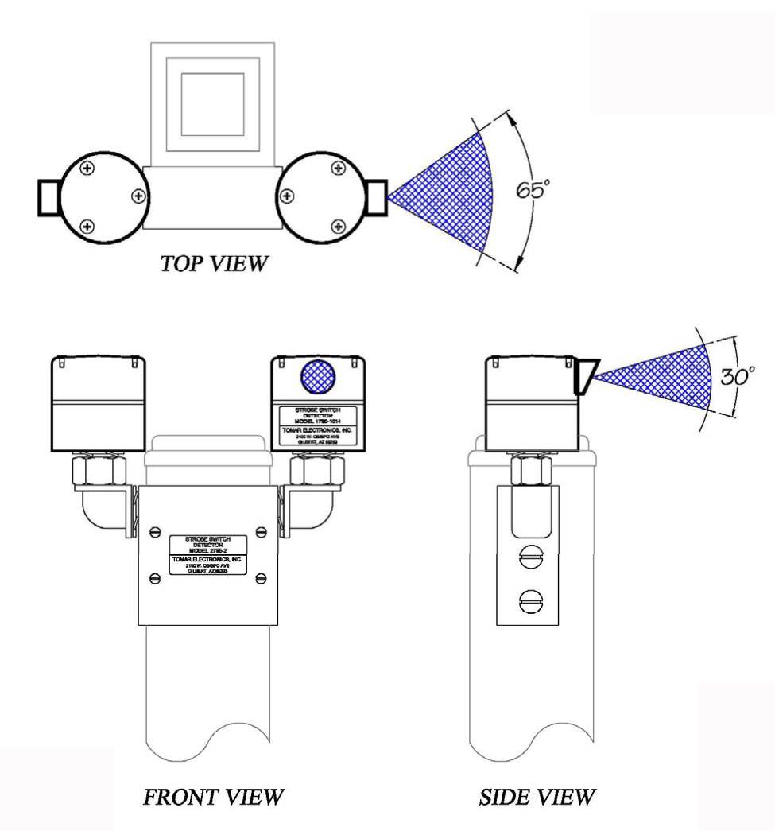

**TOMAR PREEMPTION DETECTOR MODEL 2795-3**

**(or equivalent)**

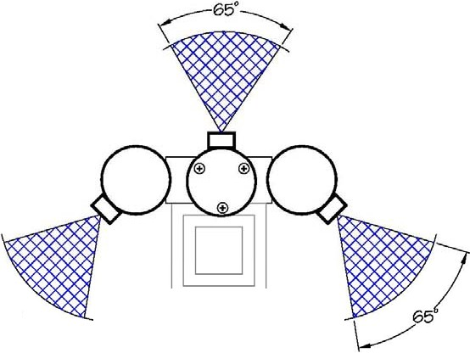

TOP VIEW

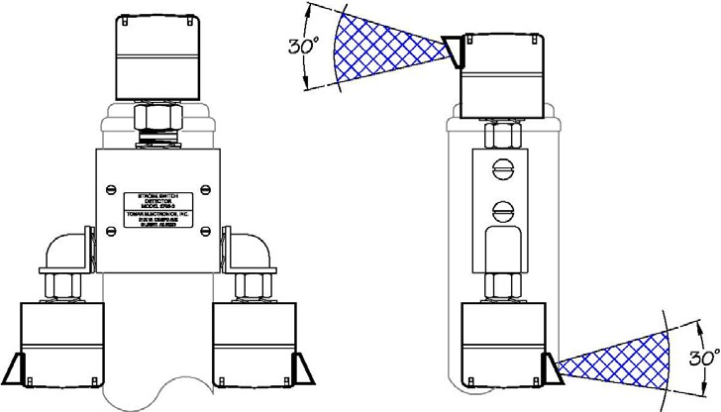

SIDE VIEW

FRONT VIEW

1. Three heads are required with 90 degree turning layouts.

**AUTOMATIC GATE STROBE DETAIL**

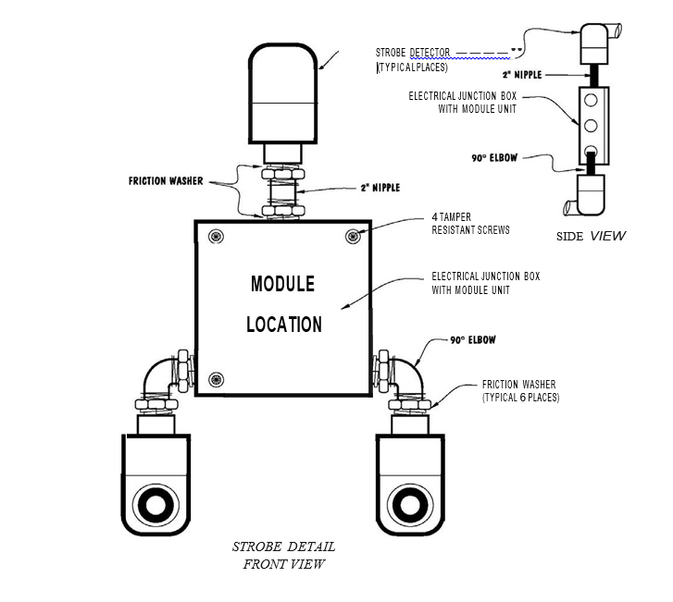

1. Three heads are required with 90 degree turning layouts.

**APPROVED AUTOMATIC FIRE DEPARTMENT ACCESS GATE PREEMPTION DETECTORS WITH KNOX KEY SWITCHES DETAIL**

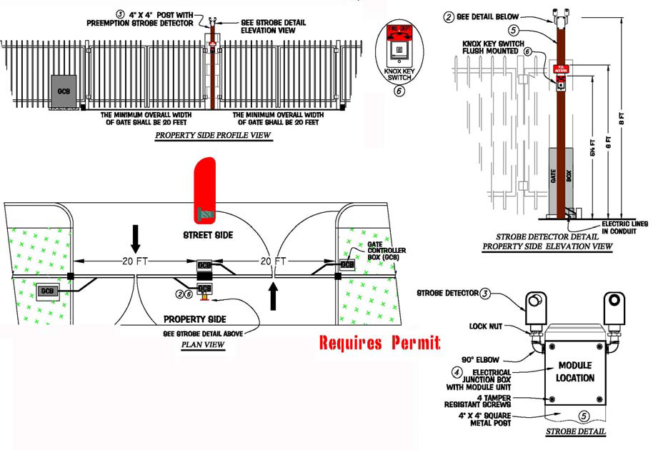

1. Each automatic gate shall have two detectors or an approved Tomar Dual Strobeswitch, model 2795-2 or equivalent. Exit gates are permitted to open with an approved approach sensor or weight sensor in lieu of preemption devices installed on the egress side.
2. Detectors shall be mounted 8 to 10 feet from grade. Mirrors shall not substitute the requirements of two detectors per gate.
3. Detectors shall point toward the path of emergency vehicles.
4. Detectors must activate at a minimum of 150 feet from gate.
5. The power module shall be mounted in an electrical junction box.
6. An approved emergency KNOX KEY SWITCH SERIES #3500 shall be installed on the entrance access gate. Switch shall be located 5½ feet to 6 feet above grade. See Chapter 4: Knox Boxes, Key Switches, Etc. for Knox ordering information.

**SPECIAL APPLICATION FOR**

**RETROFITTING WITH PREEMPTION DETAIL**

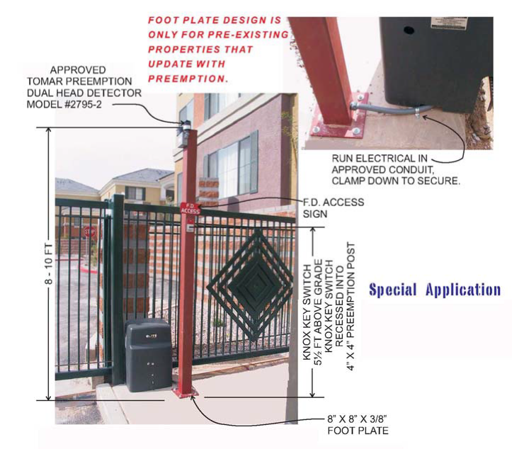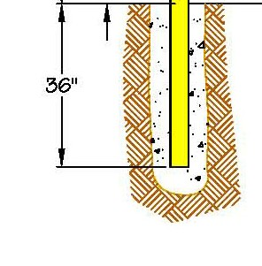

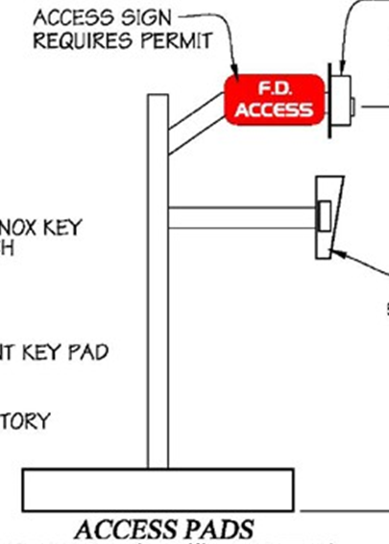

**ELEVATION DETAIL**



Knox Key Switch

See Chapter 3-10 for sign detail

1. Each automatic gate shall have two detectors or an approved Tomar Dual Strobeswitch, model 2795-2 or equivalent. Exit gates are permitted to open with an approved approach sensor or weight sensor in lieu of preemption devices installed on the egress side.
2. Detectors shall be mounted eight (8) to ten (10) feet from grade.
3. Detectors shall point toward the path of the emergency vehicles.
4. Detectors must activate within 150 feet from gate.
5. The power module shall be mounted in an electrical junction box.
6. An approved **KNOX KEY SWITCH SERIES #3500** shall be installed on the entrance access gate. Entrance switch shall be located above the key pad, if applicable, at 5 ½ feet to 6 feet from grade. See **Chapter 4: Knox Boxes, Key Switches, Etc.** for Knox ordering information.

**COMPLEX EXAMPLE**

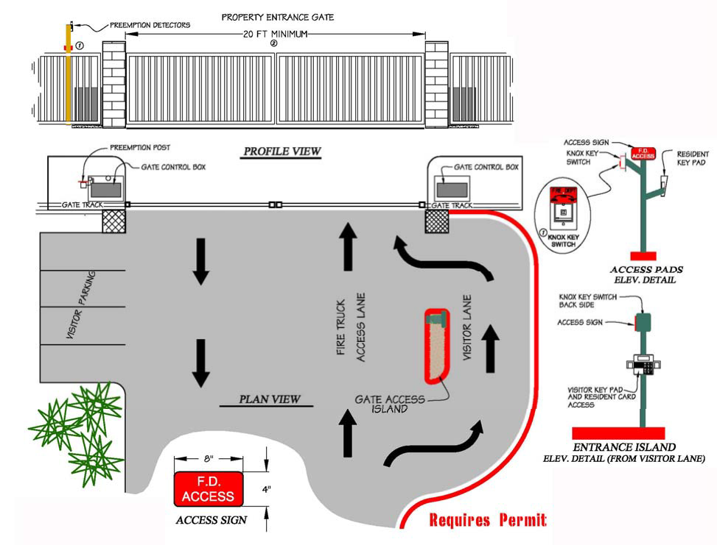

See Chapter 3-10 for sign detail

1. Provide an approved KNOX KEY SWITCH SERIES #3500 on guest key pad pedestal at the entrance and Knox key switch on preemption post on property side both installed 5 ½ feet to 6 feet above finished final grade. See Chapter 4: Knox Boxes, Key Switches, Etc. for Knox ordering information.
2. The minimum overall width of the gate opening shall be 20 feet for bidirectional access roads and 14 feet for unidirectional access roads. Notice: larger openings are preferred, if possible.

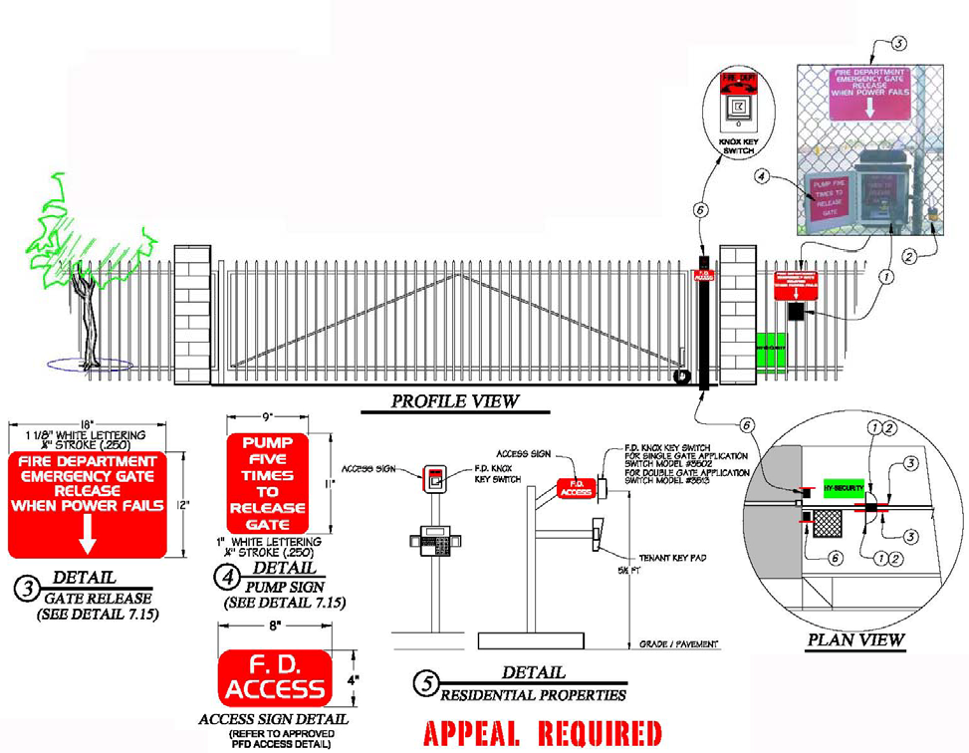AUTOMATIC GATE WITHOUT BATTERY BACK-UP

(Exception)

**APPROVAL REQUIRED**

See Chapter 3-10 for

sign detail

1. Gate release pump to be accessible from both sides of gate, three feet from gate.
2. Lock cabinet doors with an approved KNOX PADLOCK SERIES #3770, one for each door. See Chapter 4: Knox Boxes, Key Switches, Etc. for Knox ordering information.
3. Locate emergency gate release sign above pump box, on both sides of gate.
4. Locate pump sign on inside of pump box doors.
5. For residential properties – an approved KNOX KEY SWITCH SERIES #3500 shall be located on a pedestal above tenant key pad. See Chapter 4: Knox Boxes, Key Switches, Etc. for Knox ordering information.
6. The minimum overall width of the gate opening shall be 20 feet for bidirectional access roads and 14 feet for unidirectional access roads. Notice: larger openings are preferred, if possible.

RESIDENTIAL COMMUNITY ENTRANCE ISLANDWITH AUTOMATIC GATES DETAIL

See Chapter 4

for Knox ordering information

See Chapter 3-10

for sign detail

See Chapter 5

for Directory

details

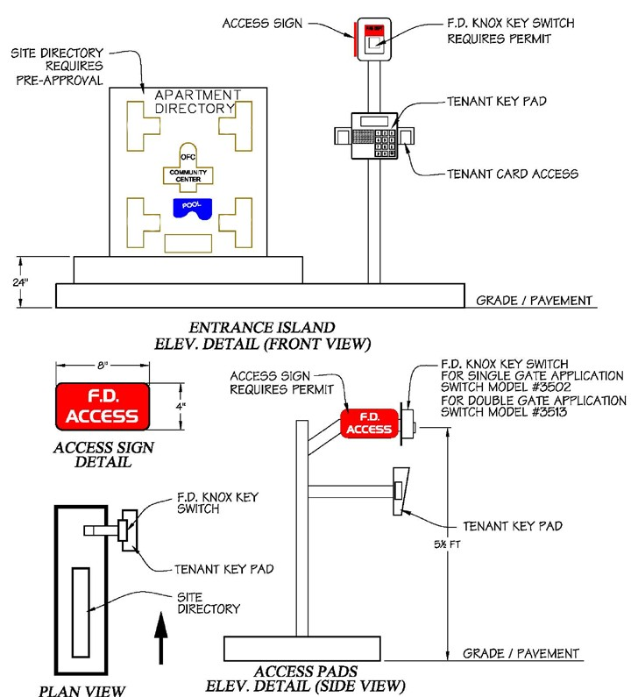

**PREEMPTION DUAL STROBE SWITCH**

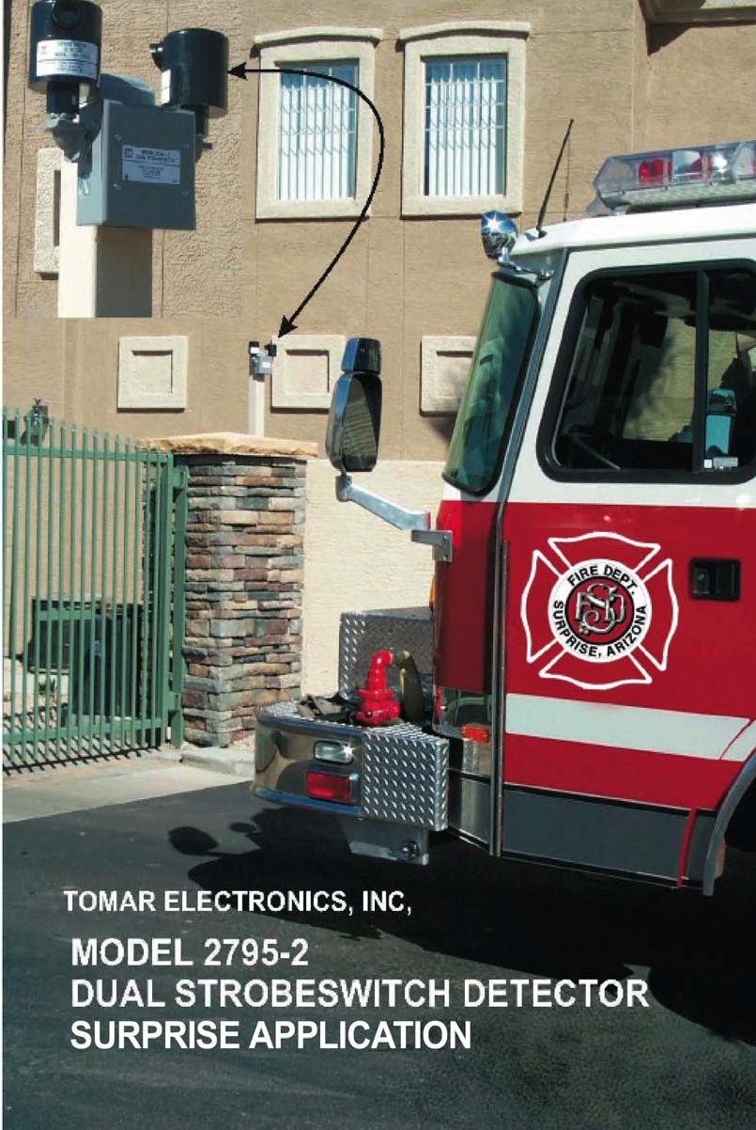**DETECTOR PLACEMENT**



**GATE MAINTENANCE**

All fire apparatus access gates shall be maintained operable at all times. Controlled access gates that are inoperable or impede the entrance of fire apparatus or emergency vehicles shall be secured in the open position until repaired or removed at the owner’s expense.

**UNPERMITTED GATE INSTALLATIONS**

Controlled access gates crossing fire apparatus access roads that have been installed without permits shall be addressed as following:

1. Secure the gate(s) in the open position until permits have been obtained and all final inspections have been performed and approved OR
2. Remove the gate(s) at the owner’s or installing contractor’s expense.