CHAPTER FIVE
Property Complex Address Directories
Contents:
- Address Directory Guidelines
- Entrance Islands into Residential Communities
- Apartment Monuments and Directories

Purpose:
A proper address directory placed at the entry of a complex aids all emergency responders attempting to find a location on a property with multiple buildings and/or suites (i.e., apartment complexes, hospital campuses).

ADDRESS DIRECTORY GUIDELINES
GENERAL
Approved graphic directories shall be provided at all driveway entrances for all multiple dwelling developments, mobile home parks, or when required by the Fire Marshal or Fire Code Official. Such directories shall be illuminated and conform to the Town of Oro Valley/Marana or Pima/Pinal County design standards and be approved by the Fire Marshal or Fire Code Official.
Prior to construction, plans shall be submitted to the Fire & Life Safety Division for review.
DIMENSIONS
The number of buildings in the complex shall determine the minimum dimensions of the directory:
- Complexes of 12 or fewer buildings require 3x3 feet (9 square feet)
- Complexes of 13 to 30 buildings require 4x4 feet (16 square feet)
- Complexes of 31 or more buildings require 5x5 feet (25 square feet)

FRAMING
Framing materials shall not encroach upon the face of the directory by more than one and one half (1½) inches. Stanchions or supports shall not be included in the required size of the directory.
PROTECTION
The directory shall be protected against vandalism and disfigurement by a clear polycarbonate cover, with a minimum of one-eighth (⅛) inch thickness, sealed to protect from weather.
ILLUMINATION
Address directories shall be illuminated, either internally or externally, utilizing white light. The directory must be illuminated from dusk to dawn.
INSTALLATION REQUIREMENTS
Support posts or stanchions shall be set in concrete. Directories with dimensions of 3X3 feet (9 square feet) shall be 36 inches above grade. Directories with dimensions of 4X4 feet (16 square feet) and 5X5 feet (25 square feet) shall be 24 inches above grade.
PROHIBITION
Information such as advertising or additional artwork shall not be permitted on the directory.

DEPICTIONS
All depictions must be clear, easily understood and legible from a distance of eight (8) feet. The directory shall depict structures, building numbers, units, apartment space numbers, tennis courts, swimming pools, canals, waterfronts, driveways, streets, laundry rooms, fire hydrants, and other areas determined by the Fire Marshal. The depictions shall comply with the following:
- Directories shall be provided at all driveway entrances for all multiple dwelling developments, mobile home parks, or when required by the Fire Marshal. Such directories shall be illuminated and shall conform to the Town of OV/Marana or Pima/Pinal County design standards and must be approved by the Fire Marshal.
- The name and address of the complex is required but shall not exceed ten percent (10%) of the total size of the site directory.
- Swimming pools, canals, and waterway areas shall be translucent blue or as approved.
- Tennis courts shall be translucent green or as approved.
- Fire hydrants shall be one-fourth (¼) inch diameter black circle filled with a translucent yellow center or as approved. The abbreviation “FH” must be affixed by the location of the fire hydrant on the directory.
- The directory shall be properly oriented to the viewer with a red symbol, one (1) inch in diameter, with the words “You Are Here” affixed at the appropriate location on the directory.
- There must be a north directional arrow affixed to the directory. This arrow must be a minimum of three (3) inches in size.
- The colors used on the site directory may not be duplicated to represent more than one item.

SETBACKS
The directory shall be installed on the occupancy’s property and at a location approved by the Fire Marshal as follows:
- The directory shall be set back from the street or curbing at least 25 feet to allow emergency vehicles to be clear of the public right-of-way;
- Shall not exceed a distance of four (4) feet from the edge of the property driveway facing the direction of oncoming traffic;
- Shall not conflict with traffic visibility zones as provided for by other ordinances;
- Shall be immediately visible and free from obstructions including architectural design and landscaping.

CORRIDOR SPREAD PLATE SAMPLE DETAIL
Number Size (Three Digit Plate)
[Three Floors]

- 4” x 5/8” brush stroke
- 3 digit numbers – hundred series
- 101-199 number range
Number Size (Four Digit Plate)
[Three Floors]

- 4” x 5/8” brush stroke
- 3 digit numbers – hundred series
Number Size (Four Digit Plate)
[Four Floors]

- 4” x 5/8” brush stroke
- 4 digit numbers – thousand series

RESIDENTIAL COMMUNITY ENTRANCE ISLAND WITH AUTOMATIC GATES DETAIL

See Chapter 3-10 for
sign detail
See Chapter 4-1 for Knox ordering info

INTERNALLY ILLUMINATED SITE DIRECTORY DETAIL

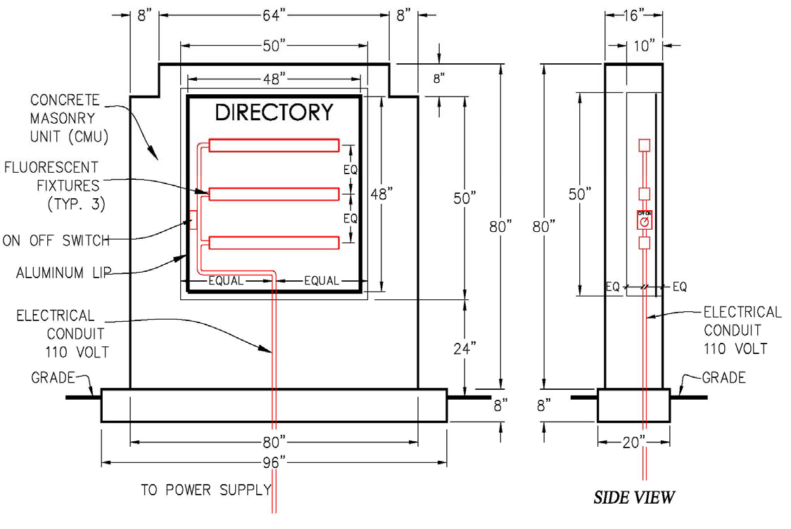

ADDRESS DIRECTORY EXAMPLE
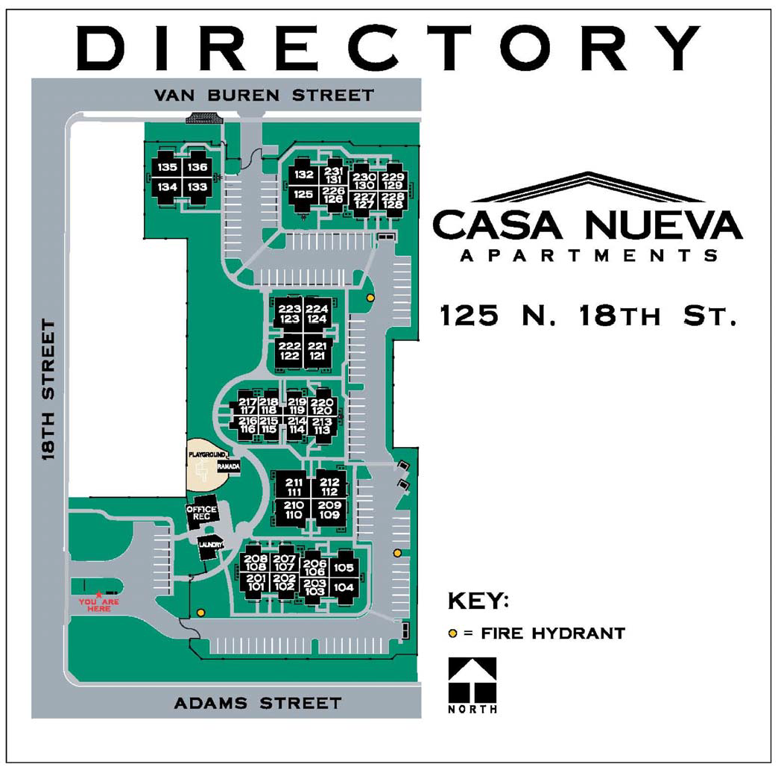
MONUMENT CROSSING
Mariposa Manor

123 Monument Crossing
Marana, AZ

520-555-1234

APARTMENT COMPLEX MONUMENT EXAMPLE
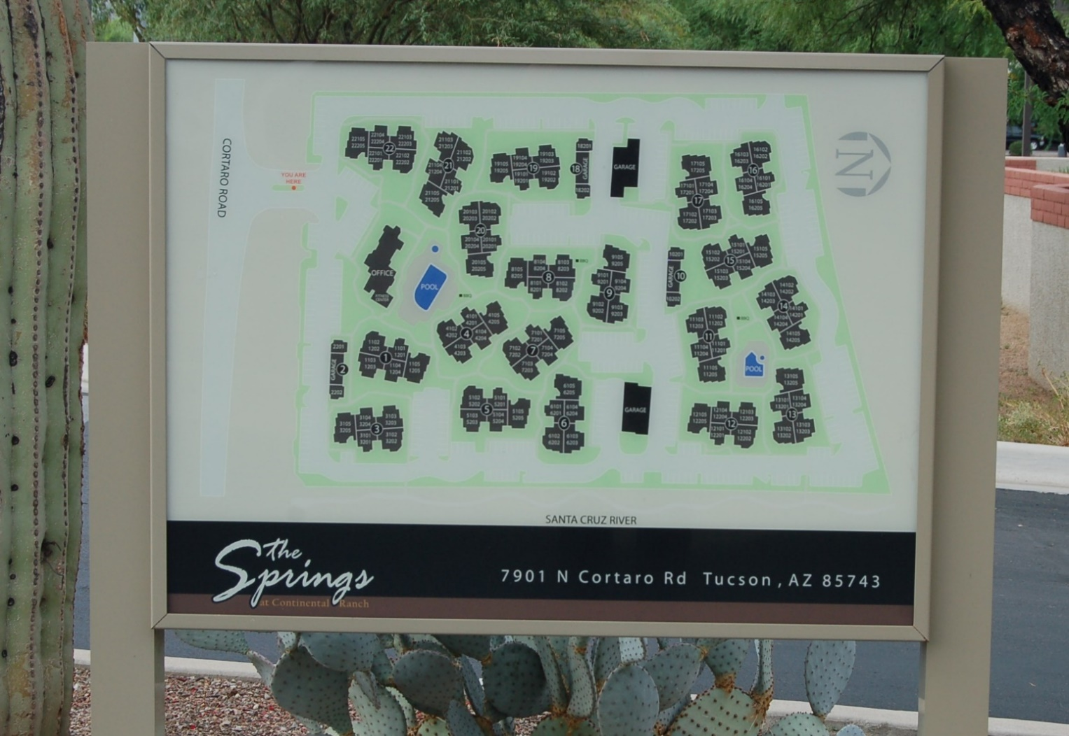

APARTMENT COMPLEX MONUMENT EXAMPLE
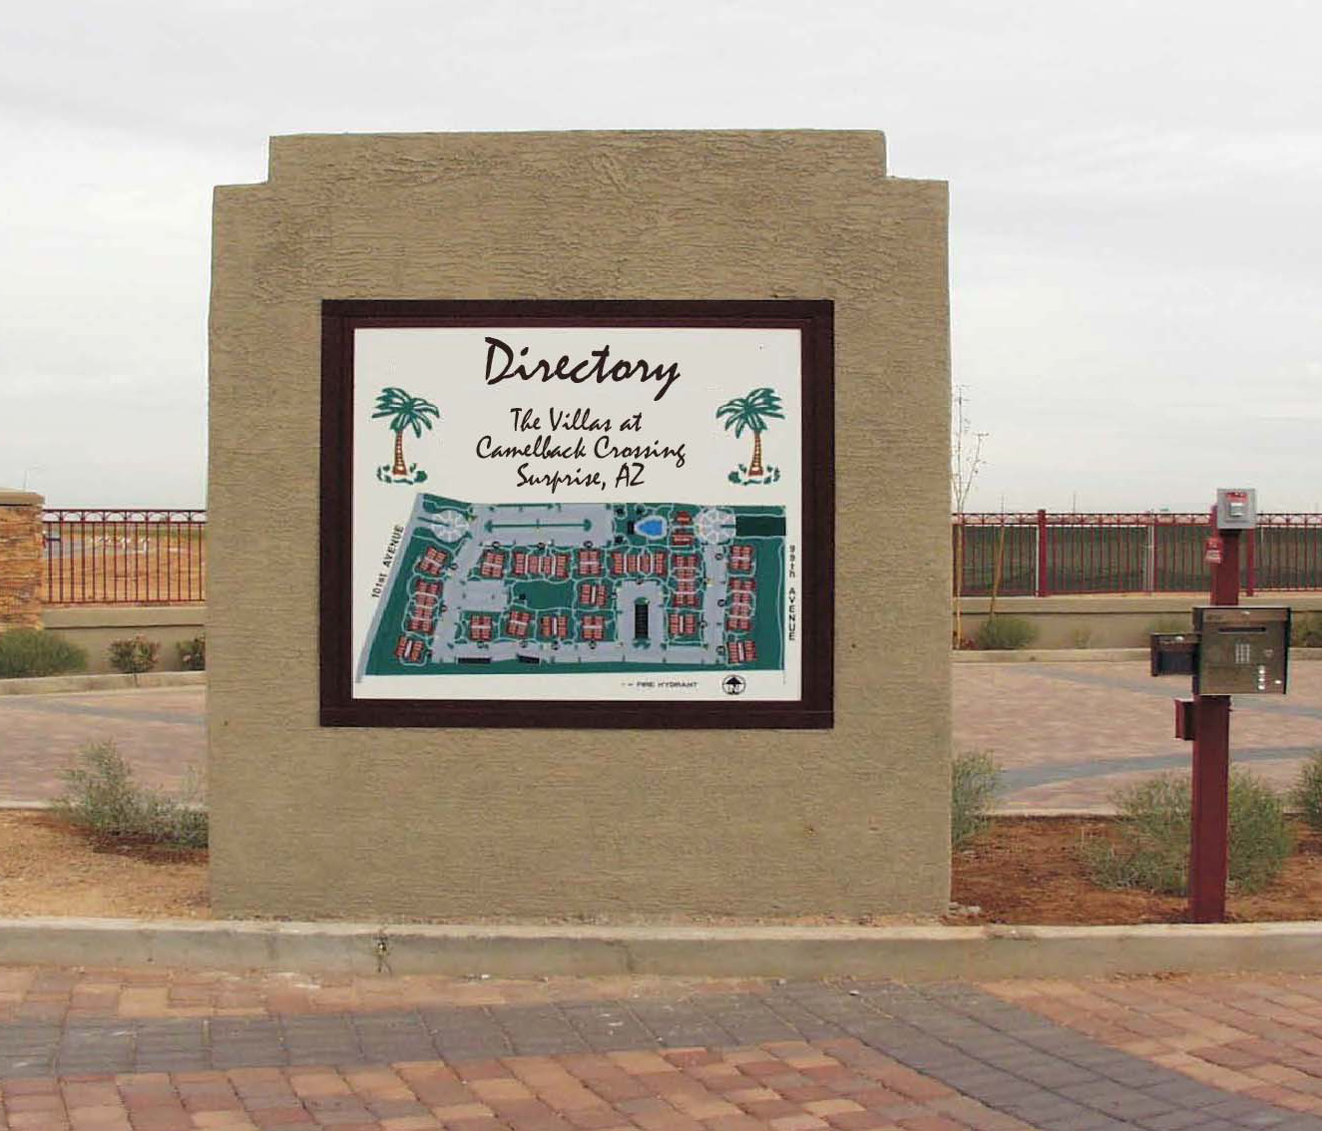
Directory
The Villas at Cortaro Crossing Marana, AZ

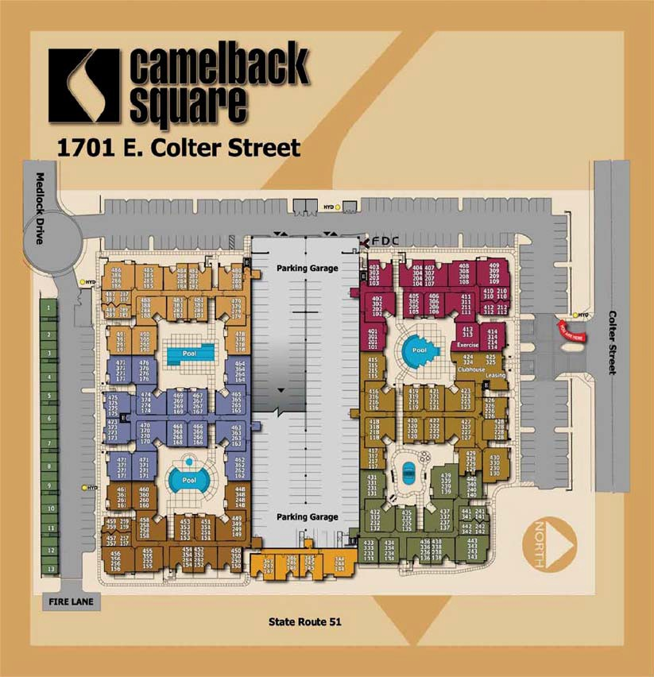
COMPLEX DIRECTORY EXAMPLE
AKINS
TOWN SQUARE COMPLEX II

