CHAPTER TEN
Residential Standpipes
Contents:
- Residential Standpipe Applications
- Required Permit and Plan Submittals
- Design Specifications

Purpose:
The installation of standpipes is essential for residential properties with access challenges such as unusually long driveways or steep slopes to prevent a delay in firefighting operations.

WHAT IS A RESIDENTIAL STANDPIPE?
Residential standpipe systems are essentially an extension of a fire hydrant system consisting of pre-plumbed piping that connects a water supply to hose connections. These systems are used by firefighters to avoid the exertion and delay from dragging large diameter hoses for long distances or traveling up steep slopes. One end of the standpipe system, with female threaded connections, is located so that an engine can pump into the pipe. The other end (or ends) will be located at key positions around the home or site with multiple outlet male connections, each with a valve. One or more standpipes may be needed to reach within 150’ of all points of the home.

WHEN ARE RESIDENTIAL STANDPIPES REQUIRED?
Driveways for residential structures greater than 200 feet in length shall comply with section 512.1 of the 2018 International Fire Code (IFC) as amended by Golder Ranch Fire District (NWFD):
- 512.1 General. Driveways exceeding 200 feet (60,960 mm) in length shall provide a minimum unobstructed width of 14 feet (4,267 mm) and a minimum unobstructed height of 13 feet 6 inches (4,115 mm). Such driveways shall not exceed 10 percent in grade.
Through an amendment to the 2018 IFC, NWFD defines a driveway as follows:
- DRIVEWAY. A vehicular ingress and egress route that connects a building or structure to a fire department access road.
When the construction of a driveway cannot comply with NWFD specifications, a residential standpipe may be installed as an acceptable alternative method to overcome the driveway deficiency. If the design option of the residential standpipe is chosen, the following requirements apply to its design, construction, and approval.

RESIDENTIAL STANDPIPE SPECIFICATIONS
- A minimum of 4-inch diameter piping system shall be used.
- All piping installed must conform to NFPA 24, 2016 edition, Table 10.1.1.1 Manufacturing Standards for Underground Pipe. Examples of acceptable piping materials include ductile iron, steel, concrete, PVC C-900 or copper.
- Thrust blocks or equivalent listed joint restraint systems are to be used at every turn greater than 45 degrees.
- A Siamese connection consisting of two-2½ inch National Standard Thread (NST), plugged female inlets are required on the fire department access end of the standpipe.
- One-2 ½ inch NST male connection with a valve is required on the residence’s end of the standpipe.
- Piping must be buried or protected in accordance with NFPA 24, 2016 edition, 10.4 Protection of Private Service Fire Mains.
- Height of connections shall be a minimum of 18 inches and a maximum of 48 inches above the finished grade.
- Standpipe risers shall require an elbow to provide horizontal orientation and may require stabilization.
- Vehicle protection guards, if required, shall consist of at least two posts, spaced 4 feet apart and 3 feet from the standpipe. The minimum post design shall be a 4-inch diameter schedule 40 steel pipe filled with concrete and imbedded in an 18-inch diameter concrete footing, a minimum of 36 inches deep.

TYPICAL STANDPIPE DESIGNS
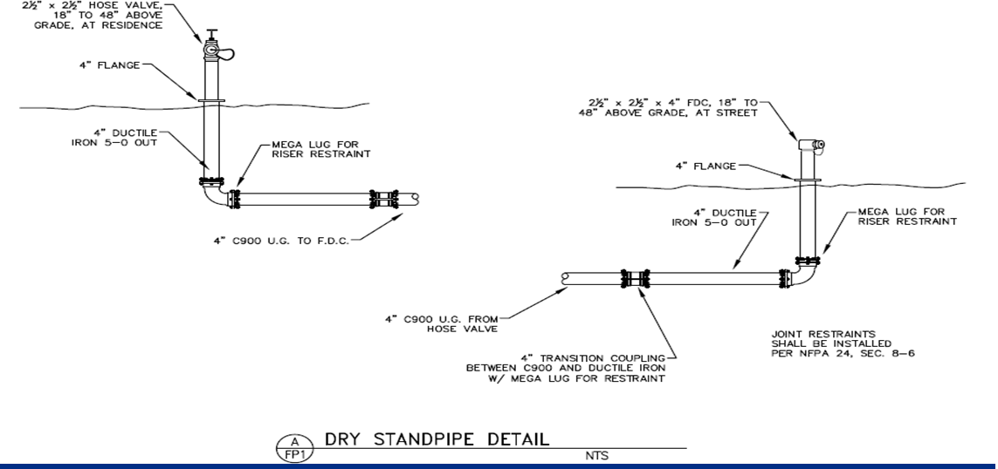

RESIDENTIAL STANDPIPE SIGN DETAIL
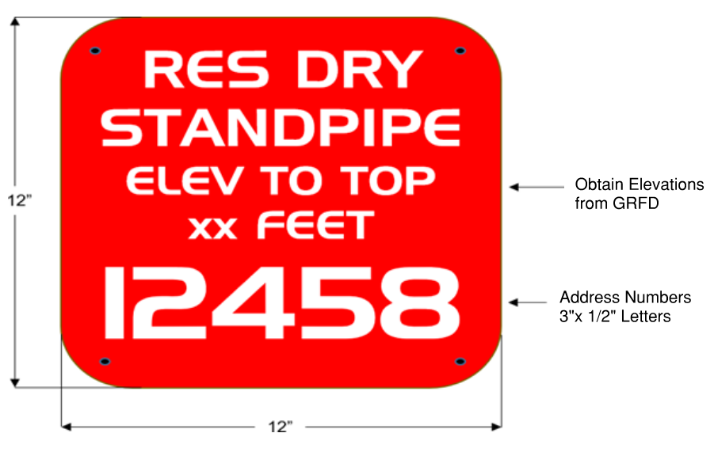
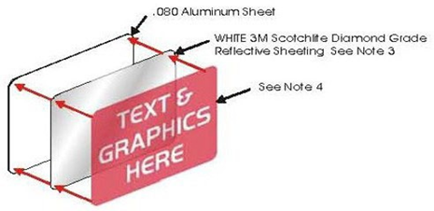
- The sign plate shall be a minimum size of 12X12 inches and fabricated from .080 aluminum sheet with 1½ inch radius corners.
- Font style is Handel Gothic capital fonts.
- The sign face shall have white 3M diamond-grade reflective sheeting 3990 series VIP, type IX) applied as a background.
- Lettering/graphics shall be one of the following:
  - 3M Scotchlite electronic transparent cuttable film (1170 series) inverse cut to allow white reflective background to show through lettering.
  - Screen printed using 3M 8801 series red translucent ink.
  - Both processes (a or b) will accomplish a red field with white copy.
- Alternate sign color may be used when approved by the Fire Code Official

RESIDENTIAL STANDPIPE SIGN DETAIL
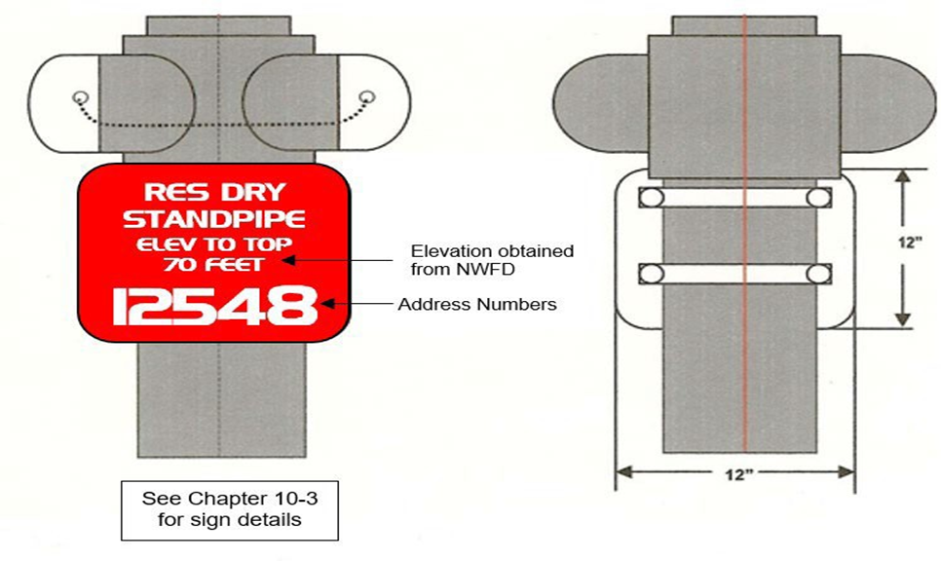
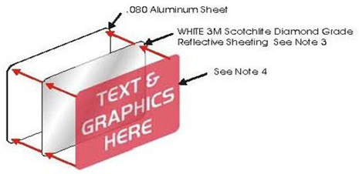
1. The sign plate shall be a minimum size of 12X12 inches and fabricated from .080 aluminum sheet with 1½ inch radius corners.
2. Font style is Handel Gothic capital fonts.
3. The sign face shall have white 3M diamond-grade reflective sheeting 3990 series VIP, type IX) applied as a background.
4. Lettering/graphics shall be one of the following:
a. 3M Scotchlite electronic transparent cuttable film (1170 series) inverse cut to allow white reflective background to show through lettering.
b. Screen printed using 3M 8801 series red translucent ink.
c. Both processes (a or b) will accomplish a red field with white copy.
5. Alternate sign color may be used when approved by the Fire Code Official

PLAN SUBMITTALS AND INSPECTIONS
Submit plans to the Golder Ranch Fire District for review and approval. Show location of risers, piping, and burial depth. Plans must specify all the materials to be used for construction of the residential standpipe system.

REQUIRED INSPECTIONS
- Pre-burial underground piping and thrust-block inspection.
- Hydrostatic pressure test. Underground piping must maintain a pressure of 200 psi measured at the lowest point in the system for a minimum of two (2) hours.
- Flush - Piping shall be flushed prior to final acceptance. Contact Golder Ranch Fire District to arrange flush.

